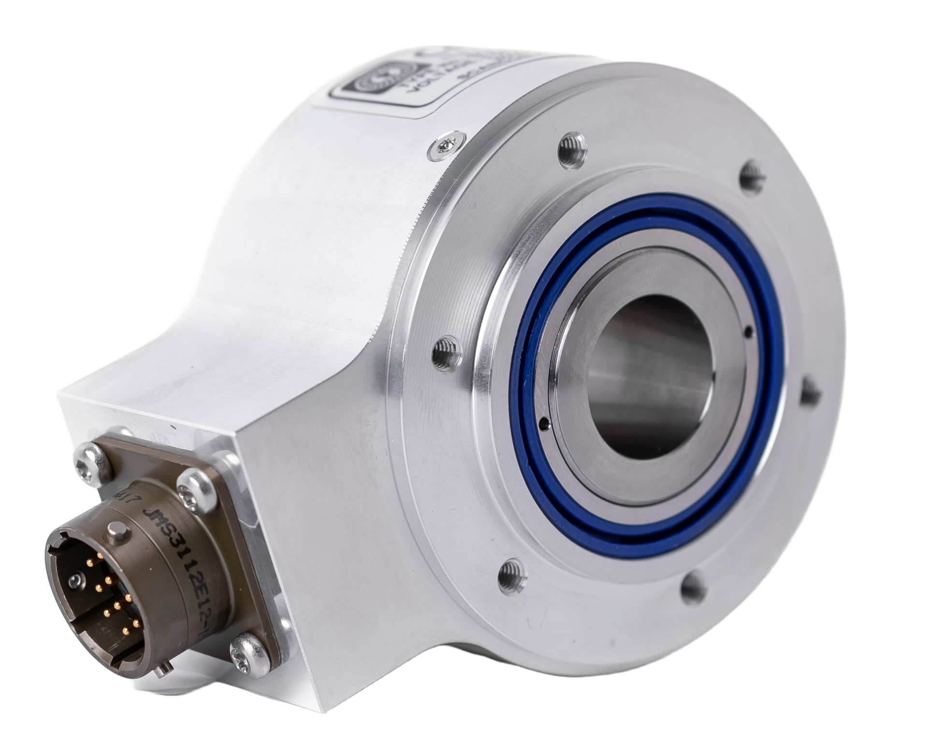

- Hollow Shaft Encoder – Ø68 mm
- Hollow Shaft: Ø 3/4 inch, Ø 1 inch
- Resolutions up to 10.000 ppr
- Delivered with cable or MIL connector
- ATEX, IECEx



Mechanical Specifications
Material: | Housing: Aluminum  Cap: Aluminum  Shaft: Stainless Steel (AISI 316)
Weight: | Encoder: Approx. 380 gr (13.4 oz)
Bearing Life: | > 1.9 x 10¹⁰ revolutions at rated load
Shaft Speed: | max. 2000 rpm
Starting Torque: | < 0.01 Nm (1.4 oz-in) at 25° C
Mass Moment of Inertia: | 440 gcm² (6.23 x 10⁻³ oz-in-sec²)
Shaft Loads: | Axial: 100 N (22,5 lbs) max.  Radial: 100 N (22,5 lbs) max.

Electrical Specifications
Code: | Incremental
Resolution: | 1 to 10,000 ppr (pulses per revolution)
Supply Voltage: | 4.5 Vdc min. to 30 Vdc max. **  (at 45 mA max. - no load)
Output Voltage: | Low: 500 mV max. at 10 mA  High: (Vsup – 0.6) at -10 mA  (Vsup – 1.3) at -25 mA
Output Current: | 30 mA max. load **  per output channel
Frequency Response: | 300 kHz max. **
Output Format: | Two channel (A, B) quadrature with Index (Z) and optional complementary (A-, B-, Z-) outputs
Phase Sense: | A leads B counterclockwise (CCW) from the shaft end of the encoder
Index: | Gated with Channel B low
Accuracy: | +/- 0.8 arc-min.
Outputs: | ASIC Push-pull and Differential  OL7272 Push-pull and Differential  Line Driver  26C31 Differential Line Driver  5V output (with 5V input)
Electrical Protection: | Output short circuit protected. Reverse polarity protected for ASIC outputs only.  (not for OL7272 or 26C31 outputs)
Noise Immunity: | EN61000-6-2: 2005 (industrial environments) Electromagnetic compatibility (EMC)  EN 61000-6-3: 2007 (residential, commercial, and light-industrial environments) for Electromagnetic compatibility (EMC)
**= It is recommended user not to combine max. Value for all 3 parameters

Environmental Specifications
Operating Temp.: | -40° to +65° C
Storage Temp.: | -40°C to +85°C
Shock: | 100g @ 11 ms
Vibration: | 10g @ 10-2000 Hz
Bump: | 10g @ 16 ms (1000 x 3 axis)
Humidity: | 98 % RH without condensation
Enclosure Rating: | IP 64 / Nema 3 (approx.) – option  IP 65 / Nema 4 (approx.) – option  IP 66 / Nema 6 (approx.) – option  IP 67 / Nema 6 (approx.) – option

Connection Options
Cable: | MUD resistant (NEK 606) & halogen free, shielded, OD Ø6.6 +/- 0.2 mm  4x2x0,14 mm², 26 AWG, 4 twisted pairs; shielded - Table 2
Connectors: | 10-pin MIL radial  10-pin MIL Bayonet radial  Table 3

SCH68BEX

Certifications
ATEX: | Certificate No.: ITS I24 ATEX39692X  II 3 G Ex ec IIC T4 Gc -40°C ≤ Tamb ≤ +65°C*
IECEx: | Certificate No.: IECEx ITS 24.0001X  Ex ec IIC T4 Gc -40°C ≤ Tamb ≤ +65°C*
EAC Ex: | N/A
* Upper ambient can be any value between +20°C and +65°C to meet customer requirements.

Table 1. Disk Resolutions (pulses per revolution)
Output waveform

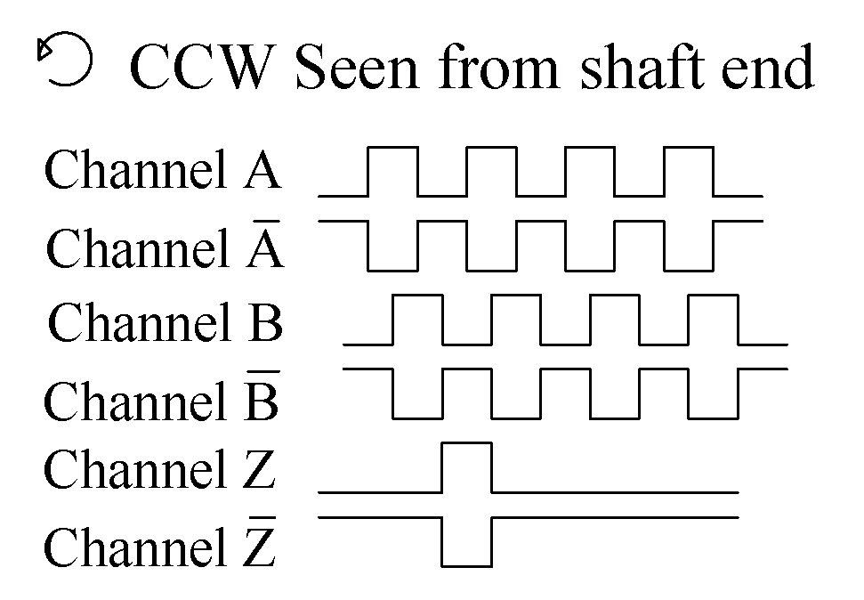
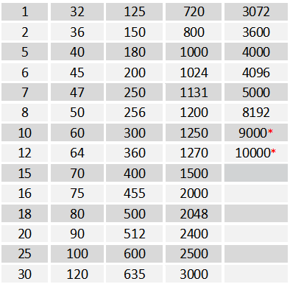

Other options on request
Pulses per revolution,
min. 1 – max. 10.000

Channel tolerance 180 e° +/- 36 e°
Phase difference tolerance 90 e° +/- 18 e°
Z channel tolerance 180 e° +/- 18 e°
* Operating temperature: -20° C to 50° C
mm (inches)
mm (inches)
MIL Bayonet connector
MIL connector
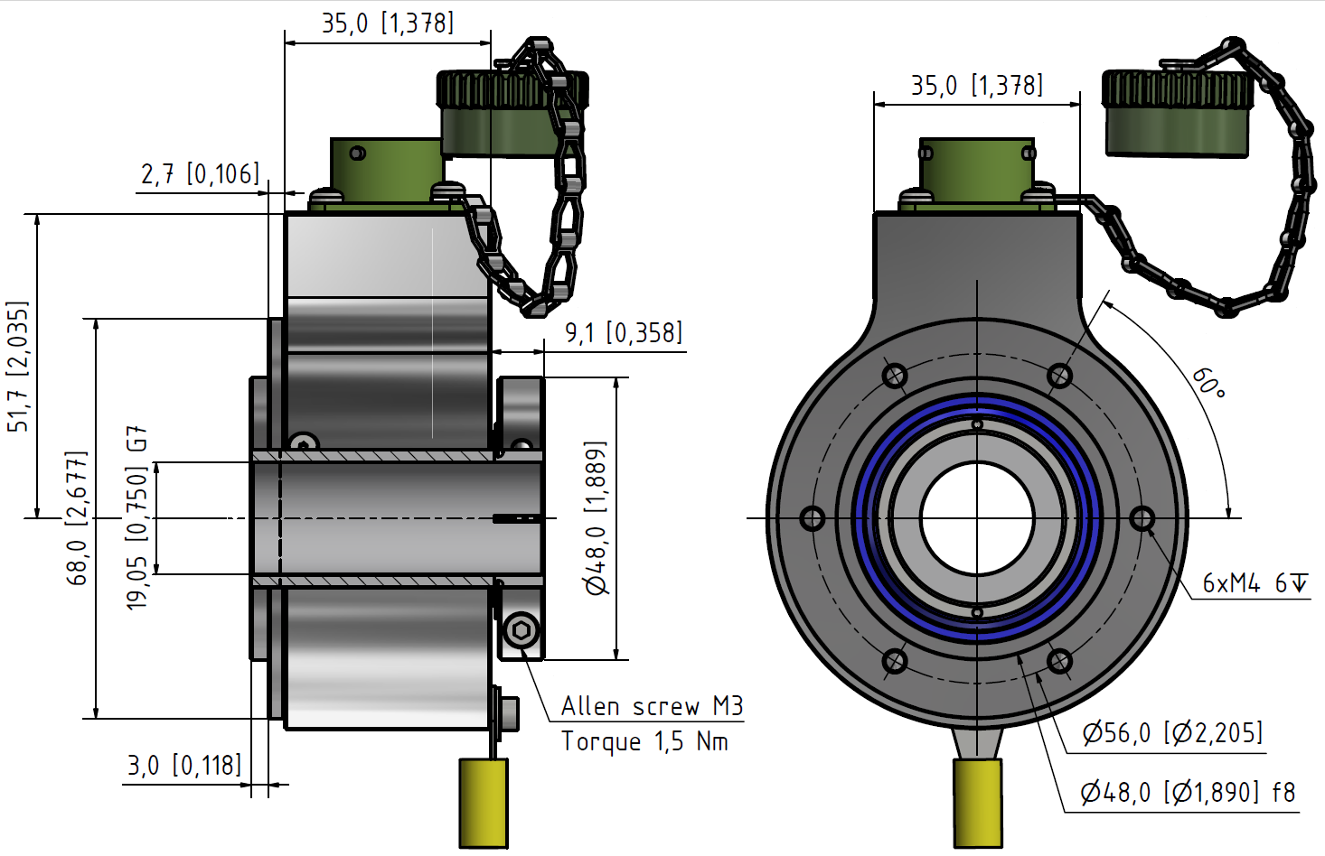
Mechanical dimensions
Mechanical Dimensions

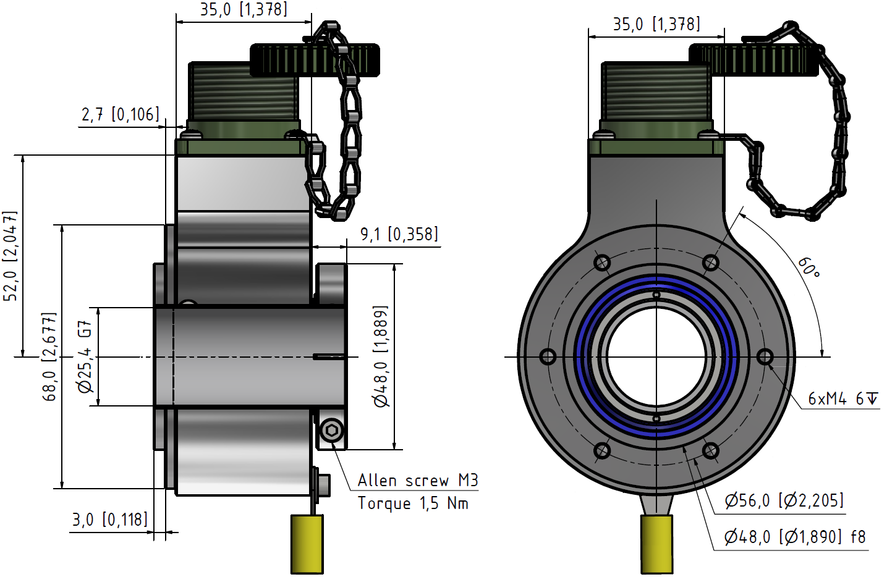
 | 10-pin MIL Bayonet |  | 10-pin Mil
 | Differential  Output | Optional  Differential  Output * | Differential  Output | Optional  Differential  Output *
Pin | Channel | Channel | Channel | Channel
A | A | A | A | A
B | B | B | B | B
C | Z | A - | Z | A -
D | Vsup | Vsup | Vsup | Vsup
E | NC | B - | NC | B -
F | GND | GND | GND | GND
G | Shield | Shield | Shield | Shield
H | A - | NC | A - | NC
I | - | - | B - | NC
J | B - | NC | Z - | NC
K | Z - | NC | - | -
Table 3. Output Terminations – MIL Connectors
Mechanical Dimensions

GND = Circuit Ground Shield = Case Ground
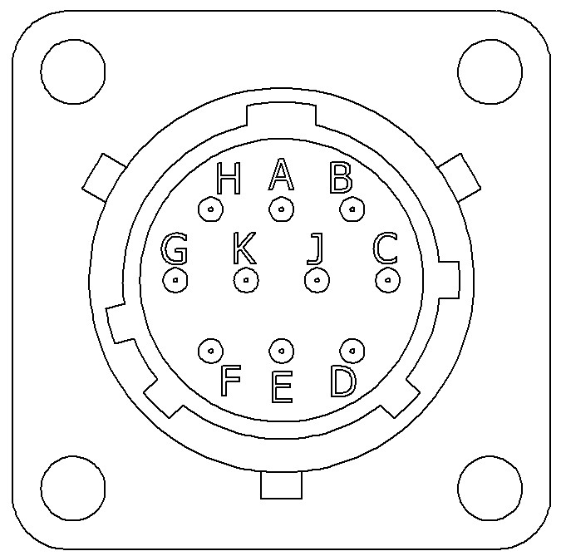
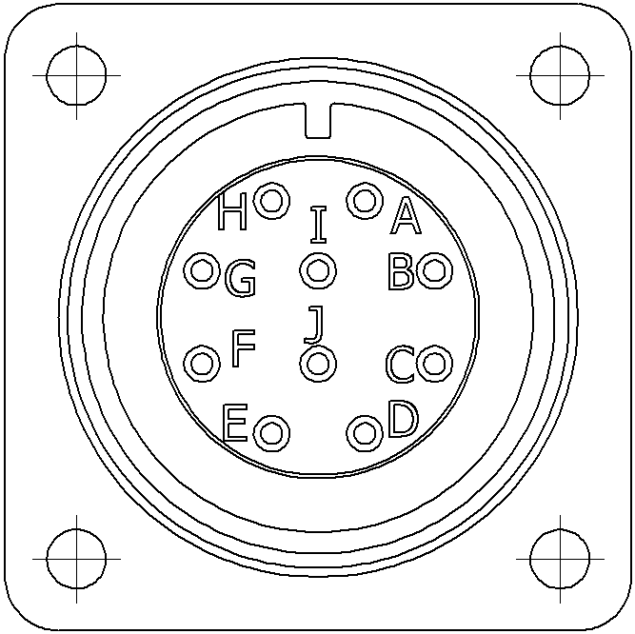
 | Standard Cable
 | Standard  Output | Differential  Output
Channel | Wire Color | Wire Color
A | Pink | Pink
A - | Gray* | Gray
B | Green | Green
B - | Yellow* | Yellow
Z | White | White
Z - | Brown* | Brown
Vsup | Red | Red
GND | Blue | Blue

* Gray, Yellow, and Brown are internally connected as Circuit Ground

GND = Circuit Ground

Shield connected to Case Ground

Cable: Shielded, 4x2x0,14 mm², 26 AWG, 4 twisted pairs;
Yellow cable shoe: AWG 12-10

Table 2. Cable Output
Mechanical Dimensions

Table 3. Cable Output

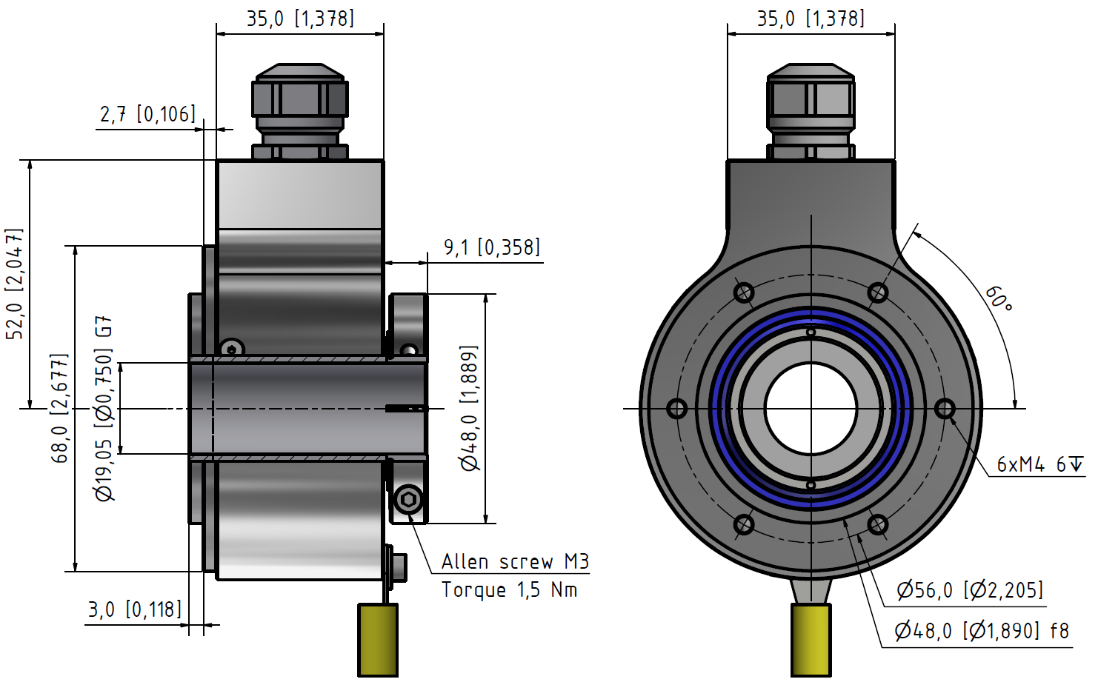
mm (inches)
Standard Cable gland

Example: SCH68BEX – 1024 – AL – D – 3/4 – 00 – 67 – 00 – B10 – A – S1
Ordering Code

SCH68BEX | - |  | - | Al | - |  | - |  | - | 00 | - |  | - |  | - |  | - | A | -
 |  | 1 |  | 2 |  | 3 |  | 4 |  | 5 |  | 6 |  | 7 |  | 8 |  | 9 |  | 10

1. Pulse per revolutions  See Table 1 on page 2 | 2. Material  Aluminum .................................. Al |  |  | 3. Output  Standard ........................................... N  Standard – open Collector NPN ...... NON  Standard – open Collector PNP........ NOP  Differential ....................................... D  26C31 Line Driver 5V only ............. L  OL 7272 Line Driver ....................... M
4 & 5 Shaft dimensions  3/4 inch x 50 mm  1 inch x 50 mm | 4.  3/4  1/1 | x  x | 5.  00  00 | 6. IP Rating  IP 64 ................................................. 64  IP 65 ................................................. 65  IP 66 ................................................. 66  IP 67 ................................................. 67
7. Cable Length  Standard cable is 1m............ 01  Specify length...................... XX  No cable............................... 00 | 8. Cable & Connector Takeout  Side Standard.......................... SS  MIL – 10-pin........................ M10*  MIL Bayonet – 10-pin........... B10**  *part # MIL MS3102E-18-10 pin  ** part # Bayonet MIL MS3112E-12-10P |  |  | 9. Flange  Flange A .......................................... A
10. Accessories

80131017 ........................ S1
80131067 ........................ S2
80132464 ........................ S3
80131062 ........................ S4
00232525 ........................ S5*
*Only for encoder with MIL Bayonet conn.

